Ideation Phase
Empathize & Discover

Date | 25 September 2026
Team ID | SWTID-2026-9367
Project Name | AI BLOGNEST API
Maximum Marks | 4 Marks

User Description
An empathy map is a simple, easy-to-digest visual that captures knowledge about a user’s A content creator or blogger who regularly creates and manages blog posts and wants to reduce the time and effort required for writing, managing, and summarizing content.

1. THINK & FEEL
What does the user think and feel?
- "I want to create quality blog content quickly."
- "Writing every blog manually takes too much time."
- "I need an easier way to manage my blog posts."
- "I want to generate content based on my topic."
- "I want to summarize lengthy content quickly."
- "I need a secure system to manage my blogs."
- "I want my content to be organized and easily accessible."
- "I want to spend more time improving my content rather than doing repetitive work."

2. HEAR
What does the user hear from others?
- Other bloggers talk about using AI tools for content creation.
- People recommend AI-assisted writing tools.
- Readers expect fresh and regularly updated content.
- Other content creators discuss the importance of efficient content management.
- Developers and creators recommend automated tools to save time.
- Users hear that secure authentication is important for online platforms.

3. SEE
What does the user see around them?
- Many blogs and content platforms available online.
- AI tools being used for content generation.
- Large amounts of online content.
- Long articles that require considerable reading time.
- Different tools for writing, storing and managing content.
- Manual blog management processes.
- Increasing demand for fast and quality digital content.

4. SAY & DO
What does the user say and do?
- Searches for topics before writing blogs.
- Writes and edits blog posts manually.
- Creates and manages multiple blog posts.
- Looks for ways to save time while creating content.
- Uses online tools to improve writing.
- Wants to generate blog content from a topic.
- Wants to summarize lengthy content.
- Organizes blogs using categories.
- Uses authentication to access personal content.

5. PAIN
What problems/frustrations does the user experience?
- Manual content creation takes time.
- Writing lengthy blog posts can be repetitive.
- Managing multiple blog posts is difficult.
- Summarizing lengthy content manually is time-consuming.
- Switching between different tools for writing and management is inconvenient.
- Maintaining secure access to blog content is necessary.
- Organizing content can become difficult as the number of posts increases.
- Creating high-quality content consistently can be challenging.

6. GAIN
What does the user want to achieve?
- Faster blog creation.
- AI-assisted content generation.
- Quick content summarization.
- Easy blog management.
- Secure user authentication.
- Centralized content management.
- Organized blog categories.
- Reduced manual effort.
- Better productivity.
- More time for improving content quality.

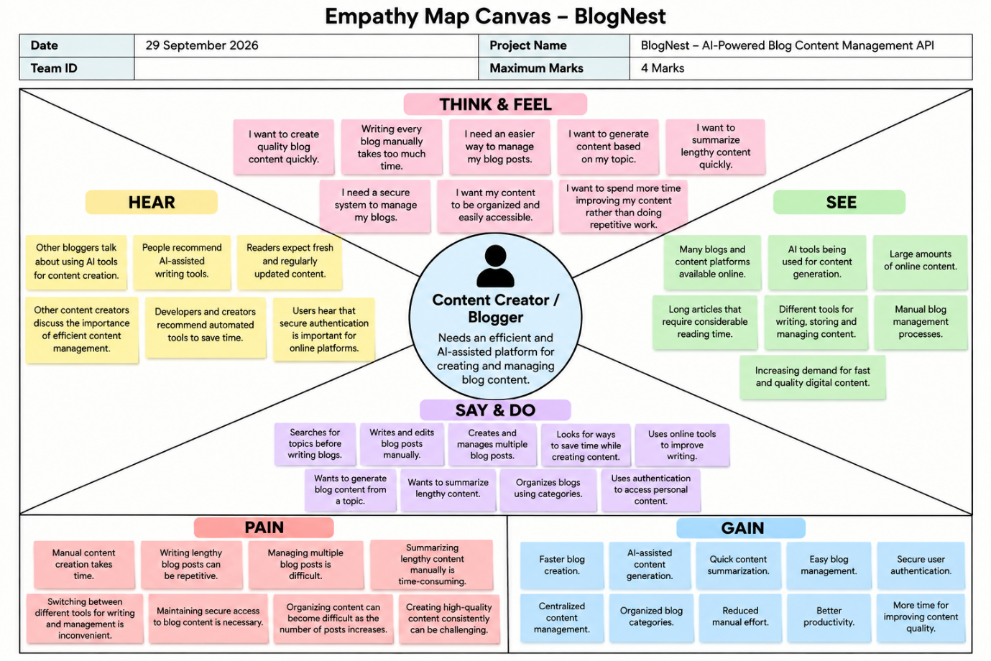
Reference: https://www.mural.co/templates/empathy-map-canvas

